Customer Support Assistants (CSA) are the first point of contact for our library customers wishing to access our services. They make sure the needs of our customers are met, and assist in the day to day delivery of Kent Libraries, Registration & Archives (LRA) services. This involves delivering outstanding customer service, signposting the public to other relevant service providers and helping to keep the libraries well presented at all times.

The CSA role includes a wide range of responsibilities including:
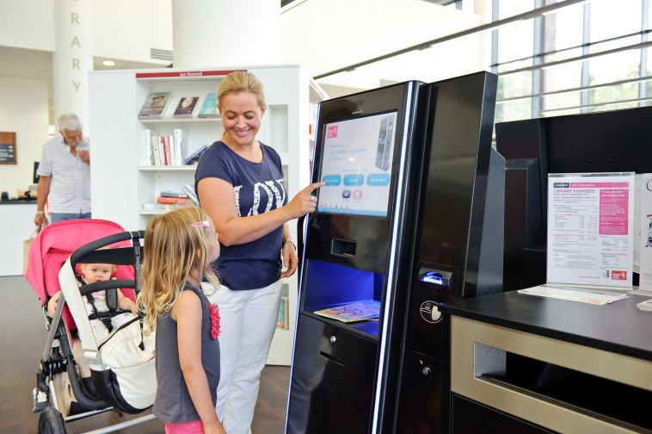
- Assisting customers to borrow, return, renew and reserve items in Kent Libraries’ physical and online loan collections.
- Promoting our digital offer to customers including audio books, e-books and e-magazines/newspapers.
- Managing customer computer bookings.
- Dealing with customer telephone enquiries.
- Creating stock displays to promote the range and variety of stock available.

Library CSAs also have the opportunity to be involved in:
- Supporting and delivering children’s activites including Baby Rhyme Time, Story Time and school class visits.
- Promoting national initiatives that encourage reading, (such as the annual Summer Reading Challenge for children), and activities that support Digital Inclusion.
- Supervising our LRA volunteers; who continue to enhance our offer by delivering a wide range of library services and activities, such as Computer Buddy assistance and the Home Library Service.

Here’s a testimonial from one of our CSAs:

“The best part of my job is being able to interact with young children. My favourite time of year is when the Summer Reading Challenge comes around – lots of eager children all wanting to take part, and being able to find something that interests them and catches their imagination. Having the knowledge that I have helped, even in some small way makes working for libraries the best”

